Major LEAGUE, Field 12

American League National League

Connor Tate Jacob Sanderlin

Andre Mathews Shane Bradshaw

Peyton Derf Jacob Gates

Grant Mahaffey Jonathan Lopez

Christopher Ward Trent Gerber

Adam Gueits Nathan Vickers

Mitchell Huggins Jr. Noah McGowan

Logan Kaufhold Dylan Taylor

Andrew Fischer Stephen Henderson

Tazman Cardiff Nicholas Piper

Jamin Minyon Aiden Warner

Fish Zabarac Austen Wright

**Coaches:** Andre Mathews **Coaches:** Bobby Sanderlin

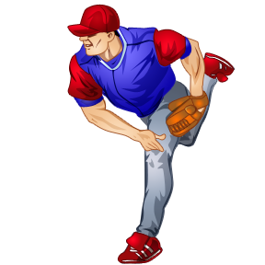

South Bryan County Recreation



Friday, May 2, 2014

5:30pm



8 Under League, field 8

**National League** **American League**

Patrick Balbo Samuel Reynolds

Drew Braman Mathew Reynolds

Ian Dunivan Tyler Fountain

Preston Beals Nathan Furman

Billy Quinny Will Hampton

Jaedin Angelino John Batson

Even Wiebold Harrison Canfield

Porter Fabre Evan Sallette

Owen Gold Gavin Martin

Bradley Barrett Tyler Scott

Zachary Bishop Conner Gilkey

Landon McDowell Noah Sybert

C.J. Gregg Aiden Roncoroni

**Coaches:** Chet Gregg **Coaches:** Brian Reddington

Minor LEAGUE, Field 9

**american League national League**

Antonio Pantigoso Gavin Prewitt

Tyler Atkins Davis Perry

Griffen Ballesteros Gabe Ingram

Niko Nichols Joey Tuttle

Austin Canfield Ethan Fuller

Seth Schulte Josh Krichten

Chase Van Ginkle Ben Durham

Zachary Farmer Michael Hortsman

Jon-Michael Williams Austen Chambers

Hayden Davis

Ty Goldrick

**Coaches:** Hayden Gorsuch **Coaches:** Mark Perry